Uptake and Incorporation of Radioactive Sulfur by Chlamydomonas

Introduction
Sulfur is an important and necessary element present in many organic molecules (Adams and Booth, 2005; Zhang et al., 2004; Leustek et al., 2000). It is a critical component of proteins, specifically proteins that contain metal ions (Zhang et al., 2004) Sulfur also plays a central role in cellular metabolism being a component of many important reductants such as glutathione and phytochelatins (Zhang et al., 2004; Leustek et al., 2000). So important is sulfur to the metabolic processes of a cell that profound and significant metabolic changes occur in its absence (Zhang et al., 2004).
Sulfur is frequently found in polyatomic form (SO₄) where it is actively transported into cells via a localized H⁺/SO₄ co-transporter system (Leustek et al., 2000). The sulfate ions are then used to manufacture amino acids (primarily cytokine and motioning), and later complete proteins (Adams and Booth, 2005; Leustek et al., 2000). Cysteine plays a central role in protein conformation being the amino acid responsible for the disulfide bridges that shape many proteins (Karp, 2005). Cysteine is also the amino acid frequently found at the active site of many enzymes (Karp, 2005). For this reason sulfur is vital to many organisms. Since sulfur is so narrowly used within the cell, it is possible to use sulfur to monitor the uptake and use of this element in protein synthesis.
In order to track sulfur as it is used within the cell, a radioisotope (³⁵S) will be used. Chlamydomonas reinhardtii will be sulfur starved and then subjected to a “pulse” of ³⁵S (Adams and Booth, 2005). The algal cells should immediately transport the radioactive sulfate into the cell and use it to manufacture sulfur containing compounds. The cells can then be fractionated and the β particles emitted by the natural decay of ³⁵S can then be measured in each fraction. In this way estimates as to the cellular uptake rate and also the rate of amino acid and protein synthesis can then be made.

Materials and Methods
Initial preparation. A culture of Chlamydomonas reinhardtii was starved for sulfur by being placed in sulfur-free TAP medium for approximately 2 hours and 40 minutes. Ten milliliters of the C. reinhardtii suspension was centrifuged for 5 minutes at 500 X g to separate the intact cells from the sulfur-free TAP medium. In order to establish a baseline radioactivity measurement, a 50µL sample of radioactive TAP solution (³⁵S, 1.25µCi/mL) was placed into a scintillation vial containing 5.0mL of scintillation cocktail (Ecovolume®;ICN Biomedicals, Inc.). This vial was labeled M0 and establishes the initial level of radioactivity in the sample. The pellet from the previously centrifuged C. reinhardtii culture was saved and resuspended with 10 mL of sulfur-containing radioactive TAP medium. This sample was divided into 1 mL portions and distributed into 3 eppendorf tubes.
Timed procedure. After 20 minutes had passed, the first eppendorf tube was centrifuged at 10,000 x g for 3 minutes to pellet the cells. Fifty microliters of the supernatant was removed and added to another scintillation vial labeled M20 (medium; 20 minutes). This sample provided a measure of the radioactive sulfur in the TAP medium after 20 minutes.
The remaining supernatant was thoroughly removed and 0.1 mL of SDS lyses solution (sodium dodecyl sulfate) was added to the remaining pellet. The pellet was gently stirred to lyse the cells. After the cells were lysed, 0.2mL of 10% TCA (trichloracetic acid) was added to the lysed cells and mixed thoroughly. An additional 0.7mL of 10% TCA was added and mixed gently. The tube was centrifuged for 3 minutes at 10,000 x g. Fifty microliters of the supernatant was removed and added to a fresh scintillation vial labeled S20 (Soluble molecules; 20 minutes). This sample provided a measure of the radioactive sulfur present in heavier soluble molecules, presumably amino acids.
The remaining supernatant was again thoroughly removed and 0.2 mL SDS lyses solution was added and completely mixed. An additional 0.8 ml of SDS lyses solution was added and again mixed. A 50µL sample of the resuspended precipitate was placed in a scintillation vial and labeled P20 (Precipitate; 20 minutes). This final sample provided a measure of the radioactive sulfur present in the heaviest precipitate molecules which ideally are complete proteins.
The entire timed procedure was then repeated at 40 and 60 minutes using the two remaining eppendorf tubes containing the radioactive medium and C. reinhardtii culture. In this manner, the uptake and use of radioactive sulfur can be traced as the cell assembles simple molecules into complex proteins. At each time interval the sample is essentially fractionated into weight classes. The lightest molecules end up in the “M” fraction. Heavier molecules end up in the “S” fraction and the heaviest in the “P” fraction. A total of ten samples were collected (M0,M20,M40,M60,S20,S40.....etc.). These samples were analyzed for one minute in a liquid scintillation counter and automatically corrected for background radiation.
Results
To smooth variations in the data, two groups performed the experiment simultaneously. The results from both groups were averaged together. Figure 1 shows the average counts per minute of each sample in 20 minute intervals over 60 minutes.

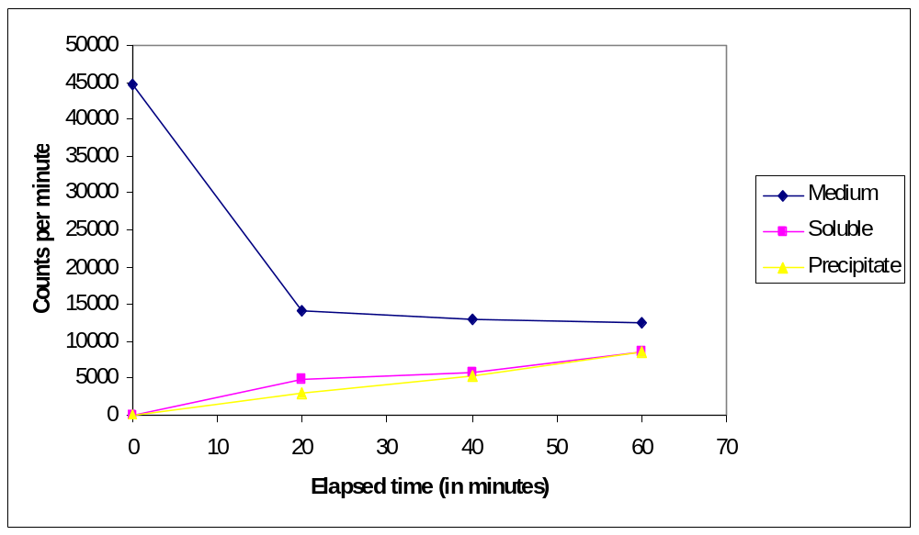
Figure 1: Counts per minute from each sample over 1 hour in 20 minute intervals

As figure 1 illustrates, the radioactivity in the growth medium declined by nearly 30,000 cpm in the first 20 minutes. During the next 40 minutes the radioactive sulfur medium declined by only 1,500 cpm. Only 17,000 cpm were detectable in the soluble molecule and precipitate fractions by the end of one hour (figure 1).
Discussion
As figure 1 demonstrates, the rate of sulfur uptake was 1534 cpm/minute for the first 20 minutes. After 20 minutes the rate of sulfur uptake was reduced in the medium to 80 cpm/minute for the remaining 40 minutes. Essentially, the radioactivity in the medium was being reduced as the algal cells took in sulfur and incorporated it into cellular components. It would logically follow that the radioactivity would increase in the fractions of the cells that contain larger cellular components as cells assembled sulfur into macromolecules. As figure 1 demonstrates, radioactivity did increase in the amino acid dense soluble molecule fraction. The precipitate fraction contained the heaviest molecules (assembled proteins) and also showed an increase over 60 minutes but at a lesser rate than the soluble fraction (figure 1). These results are consistent with processes that are known to continuously occur within the cell. As materials are brought into the cell they are assembled into amino acids and then into proteins by cellular machinery.
Knowing how the radioactive sulfur was being used doesn’t necessarily mean we were able to account for all of it. If the counts per minute are added from each sample at 60 minutes are added together and compared with the M0 sample it is apparent that nearly 15,320 cpm are left unaccounted for. Errors in separating supernatant from pellet probably account for a majority of the discrepancy.
Despite errors in measurement, the total rate of sulfur uptake can be calculated from the sulfur-medium radioactivity level. The measurement of the radioactivity of the sulfur medium provides a more accurate way of determining the sulfur uptake of the cells. It is doubtful that the sulfur was being dissipated in any way other than by cellular uptake. The radioactivity present in the medium should be a fairly accurate indication as to the rate of sulfur uptake. Using the appearance of ³⁵S in the cell fractions is a more inaccurate way of measurement, since errors in handling can cause wide variations in measurements.
For the first 20 minutes, C. reinhardtii took up sulfur at a rate of 1534 cpm/minute. After 20 minutes this was reduced to 80 cpm/minute. The reason for such an abrupt shift in uptake rate has been identified in previous studies. SO₄ is brought into the cell by a specific transport system (Zhang, 2004). Under times of sulfur deprivation, C. reinhardtii cells respond by increasing the capacity of the cell to transport sulfur across the membrane through the incorporation of additional integral protein transport systems (Zhang, 2004; Leustek et al., 2000). If sulfur became plentiful the rate of uptake would be high compared to a normal cell. The additional sulfur transport proteins would work to transport more sulfur across the membrane until the cell was satiated. It is conceivable that as sulfur levels reached a normal level within the cell, the cell might disassemble and reuse the sulfur transport complexes returning the uptake rate to normal levels.
It is likely that a wide range of proteins were assembled during our experiment. Sulfur is found primarily in methionine and cysteine (Karp, 2005). Cysteine, in particular, plays a vital role in many proteins as it is the amino acid responsible for the regulatory function of many enzymes (Leustek et al., 2000). Cysteine is also the amino acid responsible for the disulfide bridges that give proteins their specific conformation (Karp, 2005).It would be difficult to pinpoint exactly what proteins were being made with sulfurs wide ranging use in protein synthesis.
If the experiment was continued for another hour it is likely that the radioactivity in the medium would have continued to decline as sulfur was utilized. The soluble fraction radioactivity would probably increase very slowly until a plateau was reached. The precipitate fraction would likely continue beyond the soluble fraction until all of the sulfur in the medium was used. If the experiment was continued it would start to resemble an equilibrium labeling experiment because eventually the algal cells would reproduce and the rate of sulfur uptake would be reduced.

Literature Cited

Adams, M. and C. Booth. 2005. Uptake and incorporation of Radioactive Sulfur by Chlamydomonas. Unpublished laboratory manual. Biology dept. ECSU, Willimantic.

Leustek, T., Martin, M.N., Bick, J., and J.P. Davies. 2000. Pathways and regulation of sulfur metabolism revealed through molecular and genetic studies. Annu. Rev. Plant Physiol. 51:141-65.

Karp, G. 2005. Four Types of Biological Molecules. In: Cell and Molecular Biology. 4th ed. Hoboken, N.J.: John Wiley and Sons. p. 50-55.

Zhang, Z., Shrager, J., Jain, M., Chang, C., Vallon, O., and A.R. Grossman. 2004. Insights into the survival of Chlamydomonas reinhardtii during sulfur starvation based on microarray analysis of gene expression. Eukaryotic Cell. 3(5): 1331- 1348.

